UAT FUNCTIONAL SPECIFICATION
User Acceptance Testing
Functional Specification Document (FSD)
PROJECT
Automated Network Request Management

Date
Team ID
Project Name | Automated Network Request Management
Maximum Marks

1. Document Control
Field | Details
Project Name | Automated Network Request Management in ServiceNow
Document Type | User Acceptance Testing – Functional Specification Document
Platform | ServiceNow
Document Status | Draft for Review
Version | 1.0

2. Purpose
This Functional Specification Document (FSD) defines the scope, requirements, and acceptance criteria for User Acceptance Testing (UAT) of the Automated Network Request Management solution in ServiceNow. It ensures that business stakeholders validate the automated workflow against real-world scenarios before the solution is promoted to production.

3. Scope

3.1 In Scope
- End-to-end submission of user-initiated network requests through the ServiceNow portal / Virtual Agent.
- Automated classification, prioritization, and routing of requests.
- Automated approval and fulfillment for low-risk, rule-qualifying requests.
- Manual approval routing for high-risk or exception requests.
- Generation of audit-ready change records and CMDB updates.
- Real-time status visibility to requesters and stakeholders.

3.2 Out of Scope
- Physical network hardware provisioning outside the ServiceNow workflow.
- Third-party ticketing systems not integrated with this project.

4. Functional Requirements Summary
Req ID | Requirement | Priority
FR-01 | System shall allow users to submit a network request via self-service portal or Virtual Agent | High
FR-02 | System shall automatically classify and prioritize submitted requests | High
FR-03 | System shall auto-approve and fulfill low-risk requests without manual intervention | High
FR-04 | System shall route high-risk requests to the appropriate approver | High
FR-05 | System shall create an audit-ready change record for every fulfilled request | High
FR-06 | System shall update the CMDB accurately upon change completion | Medium
FR-07 | System shall provide real-time status updates to the requester | Medium
FR-08 | System shall log all automated decisions for audit and compliance review | High

5. UAT Process Flow
The diagram below outlines the end-to-end UAT process, from entry criteria and test case preparation through business-user execution, defect resolution, and final sign-off before go-live.
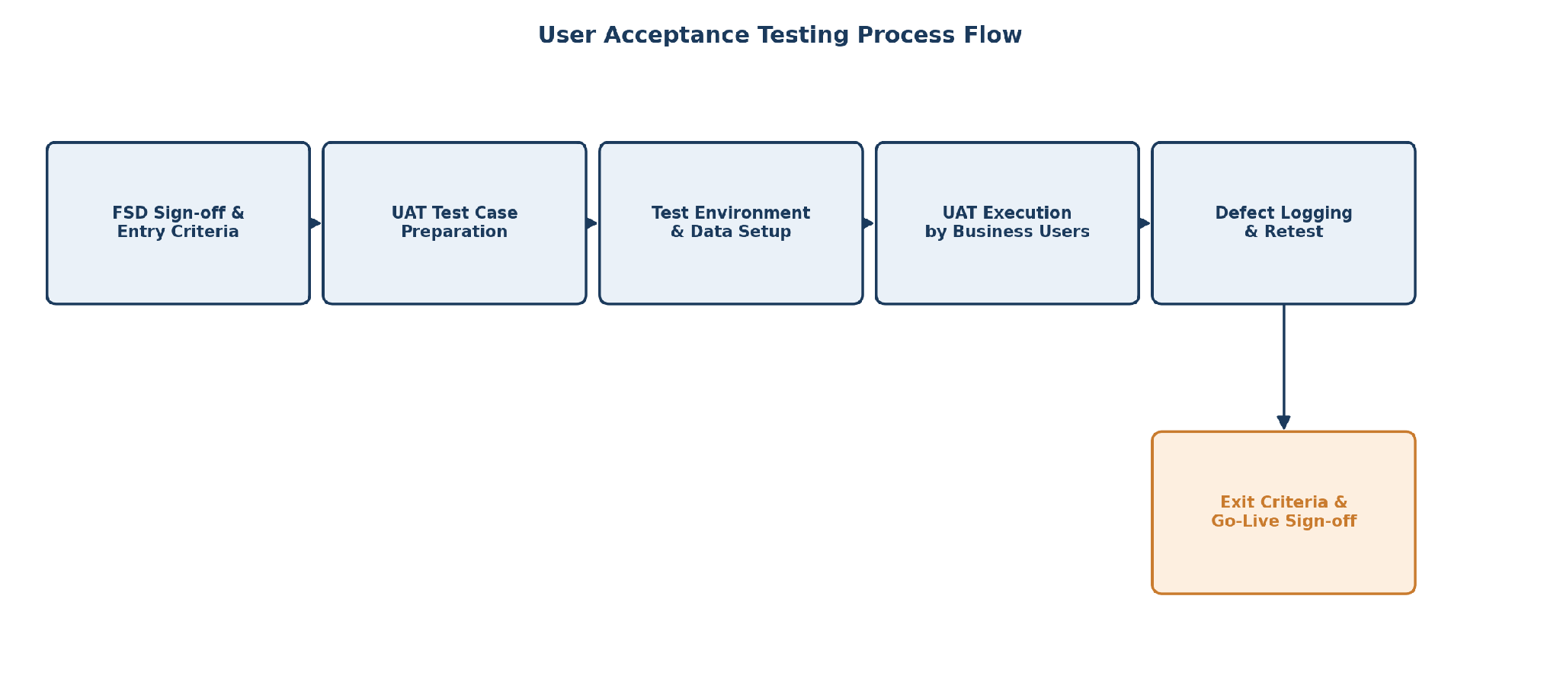
Figure 1: User Acceptance Testing process flow

6. UAT Test Scenarios
Scenario ID | Description | Expected Outcome
UAT-01 | Business user submits a standard, low-risk network access request | Request is auto-classified, auto-approved, and fulfilled within SLA
UAT-02 | Business user submits a high-risk network change (e.g., core infrastructure) | Request is routed to a human approver, not auto-fulfilled
UAT-03 | Approver reviews and approves an escalated request | Request proceeds to fulfillment and change record is generated
UAT-04 | Requester checks status mid-process | Accurate, real-time status is displayed
UAT-05 | Auditor reviews a completed request | Change record and approval trail are complete and audit-ready
UAT-06 | CMDB is checked after fulfillment | Configuration data reflects the completed change accurately

7. Roles and Responsibilities
Role | Responsibility
Business / End Users | Execute UAT test scenarios and validate real-world usability
Project / QA Team | Prepare test scripts, coordinate test cycles, and log defects
Network Operations Team | Validate fulfillment accuracy and change record quality
Project Sponsor | Provide final UAT sign-off for go-live approval

8. Entry and Exit Criteria

8.1 Entry Criteria
- Functional and performance testing (including GenAI-assisted testing) completed successfully.
- UAT environment configured with representative test data.
- UAT test scenarios reviewed and approved by stakeholders.

8.2 Exit Criteria
- All critical and high-priority UAT scenarios executed and passed.
- No open critical or high-severity defects.
- Formal sign-off obtained from business stakeholders and project sponsor.

9. Sign-Off
Name | Role | Signature | Date
 | Business Owner
 | Project Manager
 | QA Lead

10. Conclusion
This UAT Functional Specification Document ensures that the Automated Network Request Management solution is validated by business stakeholders against real operational scenarios before deployment. Formal sign-off against the criteria defined here confirms the solution meets its objectives of rapid fulfillment, audit-ready change records, and accurate configuration tracking.

